SUMMER CONCERT SERIES
June 17th Our first concert of the season features our Classic Car Cruise-In. The Castaways return to entertain with their classic rock sounds.
Featured Organization – St Mary’s Church

June 24th It’s time to kick back, relax and enjoy old time country favorites and classic rock with Larry, Larry,
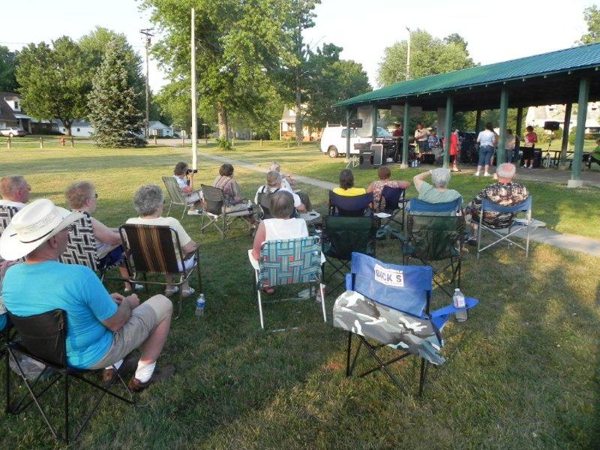
Daryl and Sheryl while we celebrate Random Acts of Kindness. Featured Organization – Country Neighbor

July 1nd Come celebrate your Patriotic Spirit and honor our American Veterans with The Great Geauga Fair Band
who will play patriotic music. Featured Organization - The American Legion

July 8th Come see our area Fire Departments, Ambulances, and Search and Rescue Dogs when we honor our
First Responders while listening to LYRA and their classic hits. Featured Organization – Area First Responders
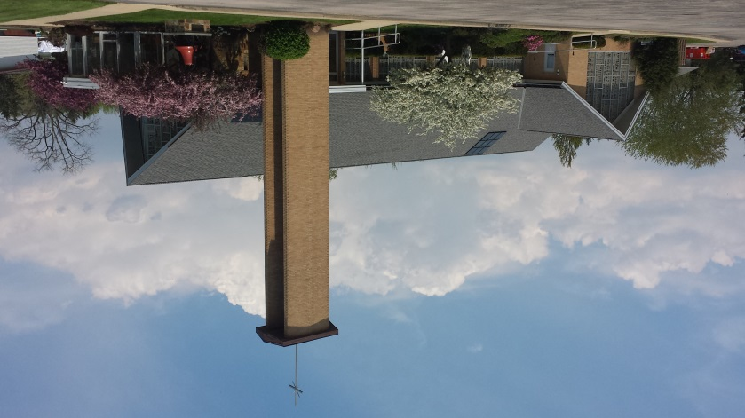

July 15th Celebrate your faith with local Christian band Saving Grace. Featured Organization, GVIS

July 22rd Let’s show our support for local Government & Business with the classic rock sounds of The King Pins.
Featured Organization - Chamber of Commerce

July 29th What better way to celebrate Community Days than with some classic country music? The Fort Huntsburg
Band is back to perform! Featured Organizations – Ruritans and Rotary
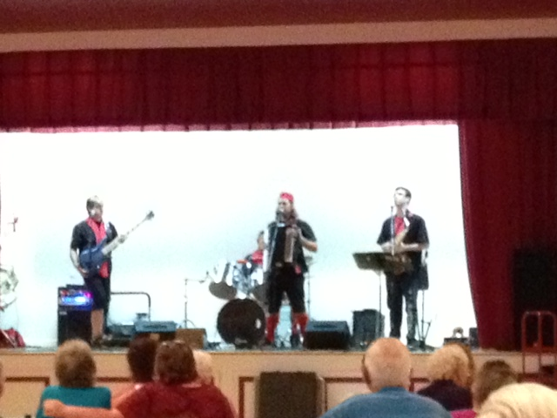
August 5th Slap on your dancing shoes and give a kind hearted welcome to Cook’s Music Menu as he plays a mix
of Country and Golden Oldies Rock while we celebrate our area parks! Featured Organization – Orwell Parks & Rec

August 12 Everybody, POLKA for a Healthier You! We begin the evening with Dale Bucar/Ralph Turek and music from
The Great American Song Book during dinner at St. Mary’s. They will be followed by the internationally known and stars
of television: The Chardon Polka Band!! Featured Organization, Conversation Station, UH Geauga

Our thanks to our Community Sponsors – without them there would be no Concerts. Stop in and tell them how much you enjoy the concerts: American Legion Auxiliary, B&S Printing, Cook’s Music Menu, Dr. Kenneth Lawrence, Farm-Credit of Mid-America, Grand Valley Chamber of Commerce, Grand Valley Drug Store, Middlefield Bank, Mordesovich Family, Orwell American Legion Post, Orwell American Legion Post Auxiliary, Orwell Oil, Valley Feed Mill, Yankee Baked Goods, Huntington Bank
A Special Thanks to Our Platinum Sponsor: University Hospitals – Geauga

CALENDAR OF EVENTS
EMPLOYEE DIRECTORY

ORWELL VILLAGE HALL
www.orwellvillage.org
Administration (440) 437-6459 (440) 437-1055 fax
Village Manager – Jack Nettis, Jr.
Clerk of Council/Finance Director – Ella Stanton
Zoning Inspector – Jack Nettis Jr.
Administrative Assistant/Tax Clerk- Linda Wyatt
Administrative Assistant/Water & Sewer Clerk – Brandy Orem
Police Department (440) 437-1234
Emergencies call 911
Police Chief – Chad Fernandez
Fire Department (440) 437-6459
Emergencies call 911
Fire Chief – Joe Albergo

Water & Sewer Division (440) 437-8398
Superintendent – Greg Hogue
Billing Clerk – Brandy Orem
Street Department (440) 437-8398
Superintendent – Mark Calabrese
COUNCIL INFORMATION
Council Members – Don Herbster (440) 437-6459
David Hartz (440) 437-8879
Dwight Johnson (440) 437-6459
Julie Mordesovich (440) 437-8331
John Rose (440) 437-8578
Solicitor – David McCombs (440) 293-6346
Find us on Facebook

July
1 Concert 6:30 p.m Chaffee Park
4 July 4th Celebrations – Enjoy your Family and Friends!
8 Concert 6:30 p.m. Chaffee Park
14 Work Session 4:30 p.m. Village Hall
15 Concert 6:30 p.m. Chaffee Park
16 Spaghetti Dinner 4:00 p.m. Am. Legion
21 Council Meeting 4:00 p.m. Village Hall
21 Planning & Zoning Mtg 7:00 p.m. Village Hall
22 Concert 6:30 p.m. Chaffee Park
25 & 26 Summer Festival Village Park
26 Chicken Dinner by OVFD Village Park
29 Concert 6:30 p.m. Chaffee Park

August
6 Summer Concert 6:30 p.m. Chaffee Park
11 Work Session 4:30 p.m. Village Hall
12 Summer Concert 4:30 – 8:30 p.m. St. Mary’s
18 Council Meeting 7:00 p.m. Village Hall
20 Spaghetti Dinner 4:00 p.m. Am. Legion

September
7 Labor Day
9 Work Session 6:30 p.m. Village Hall
TBA Council Meeting 7:00 p.m. Village Hall
17 Spaghetti Dinner 4:00 p.m.

Council Comments
By David Hartz, President
We are about to say goodbye to some very longtime public servants. With the New Year will come the retirement from Council of Charles McElroy. Mr. McElroy has spent nearly 27 years on the Council. A lifelong resident of Orwell with strong ties to the entire Grand Valley through his past employment with Key Bank and its predecessors. Charlie has served as the voice of history on the Council. He can recall past projects and situations which have been beneficial to us as we have had to make our decisions. He worked closely with me on a number of issues, but especially through the transition of government through the change from a Mayor to City Manager system. The Village owes a debt of appreciation to Mr. McElroy. Many people do not realize the amount of commitment it takes to meet regularly twice each month and to be available for the many special and emergency meetings that are required. To do so for 30 years can only be recognized as an example of a dedicated elected official and a true servant of the public.
Along with the retirement of Mr. McElroy, we will also say goodbye to Jane Byler. Jane has also been a lifelong product of the Grand Valley. She and her husband remain active in the School system. Jane served 9 years on Council and balanced family, work and completion of her nursing degree which she received in December. Jane, like Charlie, helped us work through the transition of government and I personally relied upon her as we selected our new Clerk of Council/Finance Director.
My Thanks to both Charlie and Jane for all of their support to the Village and Council.
This is also a time to welcome two members to Council: Don Herbster and Dwight Johnson. These names are not new to the Village. Don has already served for 30 years on Council and brings with him that same degree of experience and leadership that Charlie shared. He also worked with us through the financial challenges that started in 2007 and the change of government. We are fortunate to have Mr. Herbster rejoin our team.
The second new member of Council is Dwight Johnson. Dwight and his wife Brenda sought out the Village as their home over 20 years ago and has been very active in the community as a past volunteer firefighter, supporter of community activities, involvement with his church and as a member of the team that developed the new Charter for government. Dwight has been working tirelessly behind the scenes supporting our computer system and he has also been a volunteer member and chairman of the Income Tax Board.
We also welcome Julie Mordesovich back to the Council. Julie has spearheaded the new First Responders/Fire Dept. Auxiliary which has not only raised money for the safety forces but has also provided an means for our community to gather at various events.
I’m looking forward to working with this new team. Please share with them your concerns and interests.

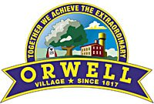
Southwest Gateway to Ashtabula County
The Village News

Summer, June 2015
Volume 11

Council Comments
By Don Herbster, President
Levies for 2015

The Orwell Village Council has spent the last several months calculating the best solutions for the November election. One levy of 1 mil is for Fire Protection. It would replace a current 1 mil levy that is expiring. It will generate about $19,000 per year. In addition to this levy a second fire levy is staggered and is not up for renewal at this time. Also, Orwell Township and Colebrook Townships have fire levies that help fund the Orwell Fire Dept.
Orwell Village’s General Fund has made major purchases over the years such as fire trucks, fire hall additions and other large expenditures. The levy monies are not sufficient for these large purchases.
The other levy on the ballot will be a 2 mil General Fund/Street Light Levy. Prior to the last five years, the levy for this purpose had been 2 mils. When it was at 2 mils, we had managed to collect more funds than was needed to light the Village. As a result, the Council was able to reduce the millage from 2 mils to 1 mil. Our balance in the fund was able, along with the 1 mil levy, to fund the street light fund. Today the proposed 2 mil levy will generate approximately $38,000 a year and we anticipate a $54,000 a year expense. We do have a small carry over balance to fill some of the gap. We will continue to monitor this situation.
I hope this gives you a better understanding of the need for these two levies.

Congratulations
Grand Valley
High School Graduates

In This Issue:
Council Comments Page 1
Village Manager Page 2 First Responders’ Auxiliary Page 3
Finance Director Page 2
Water & Sewer Department Page 2 Parks & Recreation Page 3
Police Department Page 2 Planning and Zoning Page 3
Fire Department Page 2 Grand Valley Chamber Page 3
Street Department Page 3 O-GV Chamber of Commerce Page 3

IN THIS ISSUE…
Council Comments Page 1 Water & Sewer Department Page 3
Village Manager Page 2 Parks & Recreation Page 3
Police Department Page 2 Planning and Zoning Page 3
Fire Department Page 2 First Responders’ Auxiliary News Page 3
Street Department Page 3 O-GV Chamber of Commerce Page 3 CODERED Page 3 Pictures of Santa/Concerts/Calendar Page 4

IN THIS ISSUE…
Council Comments Page 1 Water & Sewer Department Page 3
Village Manager Page 2 Parks & Recreation Page 3
Police Department Page 2 Planning and Zoning Page 3
Fire Department Page 2 First Responders’ Auxiliary News Page 3
Street Department Page 3 O-GV Chamber of Commerce Page 3 CODERED Page 3 Pictures of Santa/Concerts/Calendar Page 4

MANAGER’s REPORT
By Jack Nettis
I must begin this newsletter with a retraction from the previous one in which I said that we had a healthy carry-over fund. We still do have one but due to a computer program issue, we ended up with less of a carry-over than we had thought. The difference as reported through the computer program was: January $ 2,079,610.20 but by March, when the error was discovered, it was $1,847,715.10. The impact upon the general fund was: January $239,522.40, March $101,227.30. I emphasize this was a computer error. Our budget from 2014, and our estimated revenue and expenses for 2015, are all very close. This impacts our general fund the most.
In the planning process, having the difference between the January statement and the March statement has caused me to have to make adjustments to our Council Fund which reflects the carry-over funds. This means those projects that would be on our “wish list,” cannot be funded. In addition, I will not be comfortable with the General Fund portion of the budget until we get deeper into the year and until we complete our bi-annual state audit which is slated for early June.
We have taken on a new, major expense this past year – two employees in the Street Dept who are also members of our fire department. This is so that we can be more responsive to those critical assets such as our businesses, industries, Grand Valley School System, the Townships who pay us to support them and our residents. We are still assessing this impact upon our budget. I made the recommendation because it was proper for us to insure that we could respond during the daytime to emergencies and we were not in a position to do so. While all communities rely upon Mutual Aid from other fire departments, there is a delayed response as they travel from their home departments here and we cannot be assured of others having the volunteers available to respond to our emergencies. Our assets are too critical to not have a better response available. This is why we have taken on this burden.

Water and Sewer Department
Greg Hogue, Superintendent
At the publishing of this Newsletter you are receiving your water/sewer bill. Last quarter we saw a reduction in our late fees for those not having made payment in the 30 days after we mailed our bills. That’s good news! Over two years ago we initiated a late fee to encourage timely payment of the bill. This is finally starting to work. Such a late fee is consistent with other utility systems in other communities. We do not want to collect the extra money for the late fees, we just want to insure payment for water/sewer service and in a timely manner. We, along with the Village Administration, have cut back on our administrative staffing and we need to run a more productive and efficient operation. Please help us to do so.
The Water & Sewer Dept. runs entirely from the revenue that we generate by providing our service to our customers – our residents and businesses. The only outside revenue that we receive is from grants or loans when we take on large projects, as we did this past year with the renovation of the water tower on Oak St. We are currently analyzing our water system and the need of having the downtown (Mustang) tower in our system. If needed, it will have to be renovated soon or replaced. These are expensive prospects. We are being very methodical as we approach this next project. Already the Village Manager and I have been discussing with the County a financing strategy for the renovation or replacement of the tower. This takes a while to put into place, but it can help us financially.
Because we have been methodical and detailed in our planning of our projects, we have been able to keep our rates constant for at least 5 years. There may come a time when Council will have to consider a rate increase, but for normal operations expenses, this is not the year for such an increase.

Orwell Volunteer Fire Department
Joe Albergo, Chief
We are still plagued with grass fires this Spring and they are continuing into the summer. We do not permit outside burning. All too often, even in damp weather, we are called for fires getting out of control. In one weekend, we responded to six fires.
Our Fire Dept. works with many of the area fire departments as responders to water rescue situations. We respond all throughout the county depending upon the emergency and ability for others to respond. We have trained/qualified divers on our department. It is just one of the special skills that our firefighters spend their evenings and weekends in training.
ICE = In Case of Emergency
Did you know that first-responders will often check a victim’s cell phone for an emergency contact. The first place they look is “ICE.” Be sure to have your emergency contact listed in your cell phone.

Police Department News
By Chad Fernandez, Chief
Watch for Motorcycles
As a reminder…now that warmer weather is here, motorcyclists are out in force. Drivers are reminded to look out for and share the road with motorcycle riders, and motorcycle riders are reminded to obey traffic laws, wear DOT-compliant helmets and other protective gear, and make themselves visible by wearing bright colors using reflective tape.
Increasing safe riding and cooperation between all road users and motorcyclists will help to reduce the number of fatalities and injuries on our nation’s highways.
- Road users are reminded to never drive, bike or walk while distracted. Doing so can result in tragic consequences for motorcyclists.
- A motorcycle has the same rights and privileges as any other vehicle on the road.
- Allow a motorcyclist a full lane width. Although it may seem that there is enough room in the traffic lane for a motor vehicle and motorcycle, the motorcycle needs the room to maneuver safely. Do not share the lane.
- Because motorcycles are small, they can be difficult for other road users to see them, or judge their speed and distance as they approach.
- Always signal your intentions before changing lanes or merging with traffic. This allows motorcyclists to anticipate traffic flow and find a safe lane position.
- Because of its smaller size, a motorcyclist can be hidden in a vehicle’s blind spot. Always check for motorcycles by checking mirrors and blind spots before entering or leaving a lane of traffic and intersections.
- Don’t be fooled by a flashing turn signal on a motorcycle. Motorcycle signals may not be self-canceling and motorcyclists sometimes forget to turn them off. Wait to be sure the rider is going to turn before you proceed.
- Remember that road conditions that are minor annoyances to motorists can pose major hazards to motorcyclists. Motorcycle riders may change speed or adjust position within a lane suddenly in reaction to road and traffic conditions such as potholes, gravel, wet, or slippery surfaces, pavement seams, railroad crossings and grooved pavement.
- Allow more following distance – three or four seconds – when following a motorcycle so the rider has enough time to maneuver or stop in an emergency. In dry conditions, motorcycles can stop more quickly than cars.

First Responders Auxiliary News
By Julie Mordesovich, Chairperson
We are now enjoying some new bright sunshiny days. The First Responder Auxiliary has been busy planning events for the summer months. We will be selling hot dogs at the Safety Day Concert in the park on July 8th. We will be at the Community Days July 25th and 26th. We will be working with the Firefighters with their fantastic Chicken Dinner on July 26th. Pre-sale tickets are now available from any Firefighter. Please come and join us and support our Fire Department. Have a safe and fun-filled summer.

Would you be interested in curbside recycling?
To receive curbside recycling, the entire Village would have to have the same trash hauler. Often this results in lower monthly trash hauling fees for all and curbside recycling is included in the monthly bill.
Let the Village know if you would be willing to have a single trash hauler and curbside recycling. Comment on Facebook or drop by Village Hall.

Street Department
Mark Calabrese, Superintendent
We will continue with the sidewalk replacements. We have approximately $19,500 for new sidewalks. The sidewalks are a continuation of the Neighborhood Revitalization Grant (NRG) which was started last summer. The Village Manager is assessing our finances to determine when we will pave Park & Central and also Penniman Rd., by Kennametal. Both are in need of paving, it’s a matter of money. We expect to have a better picture after we have our state audit in early June.
We recently did crack sealing throughout the Village. This is a necessary, annual maintenance item to keep water from seeping below the roadways. This helps to prolong the roadway surface.

Parks & Recreation
Deborah Meyer
We hope you have had the opportunity to notice the enhanced flowers in our attempt to beautify the Village. These were ordered back in February and we were able to do so within this year’s budget. This along with the new parking lots, sidewalks, and facelifts to some of our downtown businesses such as Wollam-Grand Valley Insurance, Circle K, Country Neighbor and The Grand Valley Library, all add to the overall appearance and impression others have of our Village and our general streetscape. It makes a statement as we are the Southwest Gateway to Ashtabula County.
The Grand Valley Chamber of Commerce has provided some additional funding to us, and we will be doing some fundraising this summer at one of the Concerts, and at some other times, to raise money to purchase new Christmas decorations. These new items may not be purchased this year, but will take us a while through fundraisers. We hope you will join us for some of our events.

Grand Valley Area Chamber of Commerce
By President – Robert Denihan
We are pleased to see a noticeable improvement in the Grand Valley Chamber of Commerce meetings. All who are interested are invited to join us for lunch, June 23, 2015 at Noon at the Country Neighbor Building at 39 S. Maple Street, Orwell, OH 44076.
The Community Days Committee is busy with details for the two-day event on July 25 and 26, 2015. We are excited that we will have Games, Music, Crafters, and Vendors. If you are interest or would like to help, feel free to call me, Bob Denihan, at 216-408-9020 or Doris Cook at 440-376-7881.
Mark your calendars for
Community Days
July 25 & 26
OLD BRICK
Have you been to the Old Brick to see and learn about the history of Orwell.
The Old Brick Society opens the building to the public the 2nd Sunday of June, July and August from 1-4pm.

